**Exercise 2 : Implementation of Factory Method Pattern**

**Logic and Implementation Code For Factory Method Pattern :**

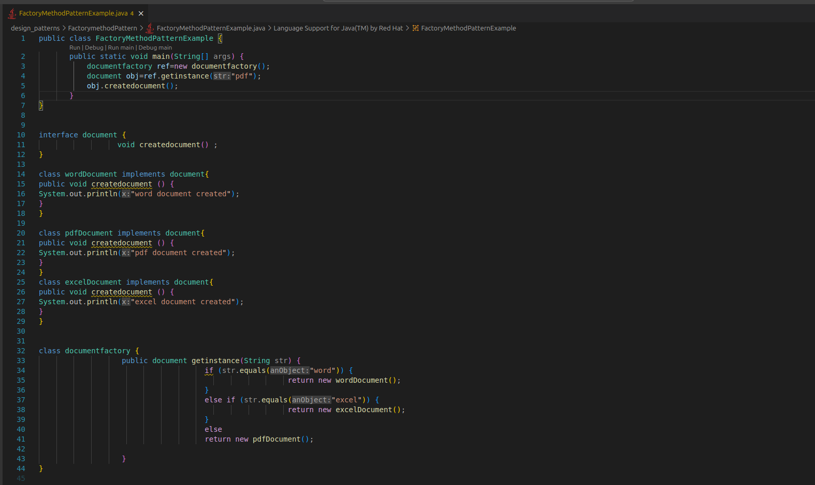

**Output** :